1. Creating and Renaming Files/Directories
Create a directory named test_dir using mkdir.
Inside test_dir, create an empty file called example.txt.
Rename example.txt to renamed_example.txt using mv
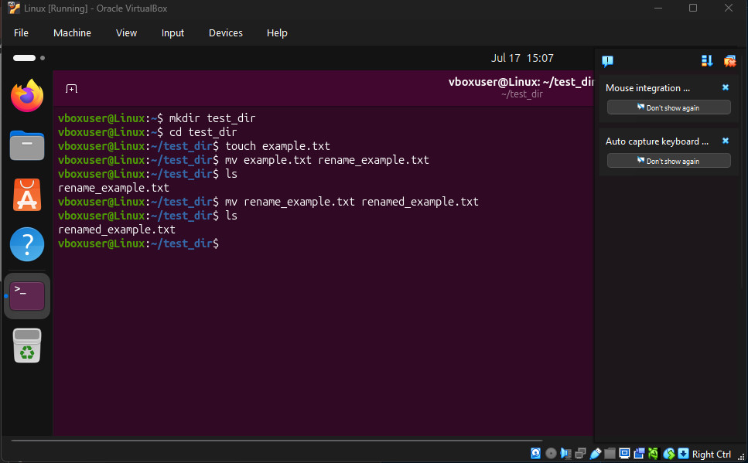

2. Viewing File Contents
Use cat to display the contents of /etc/passwd.
Display only the first 5 lines of /etc/passwd using head.
Display only the last 5 lines of /etc/passwd using tail.

First went inside etc directory
Then opened the file passwd
After that used head and tail for the lines
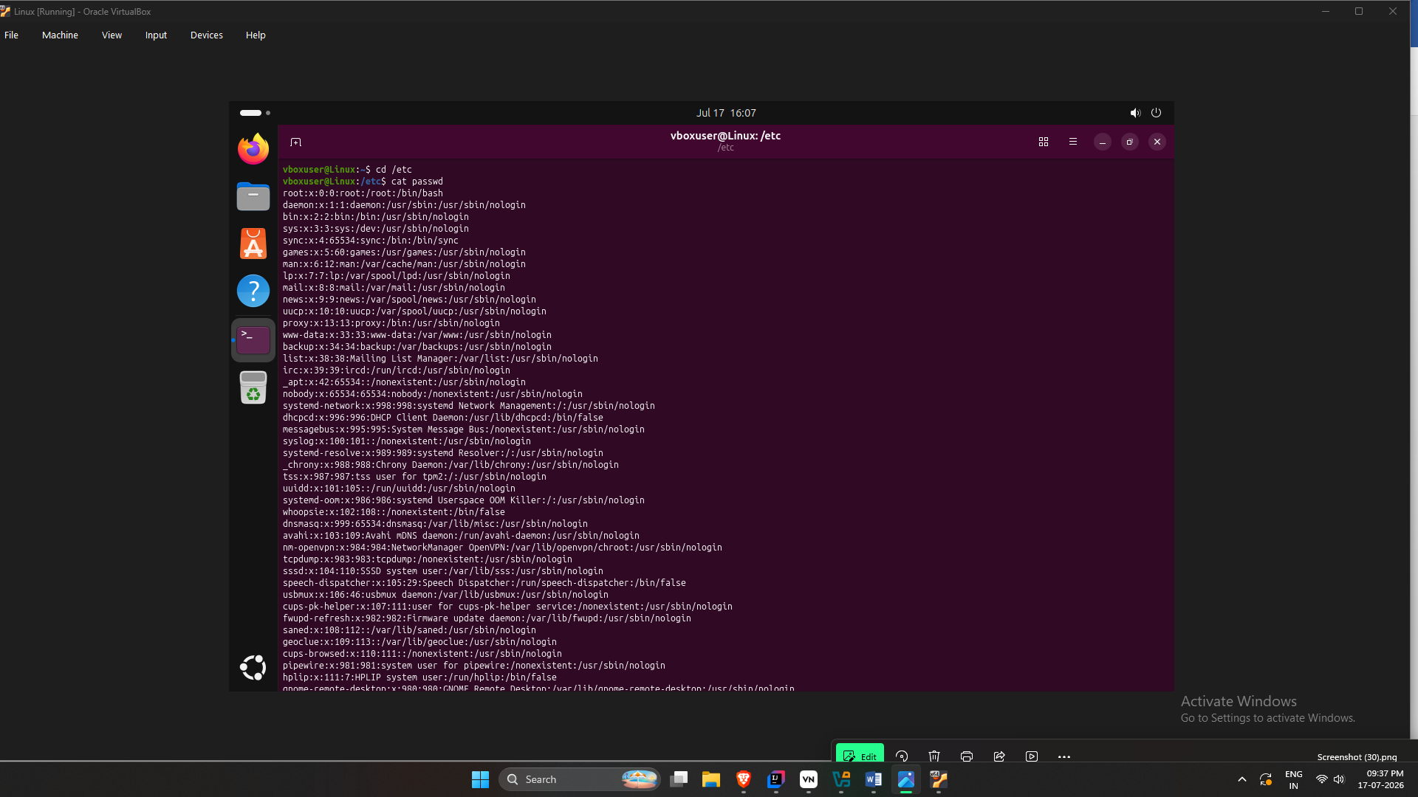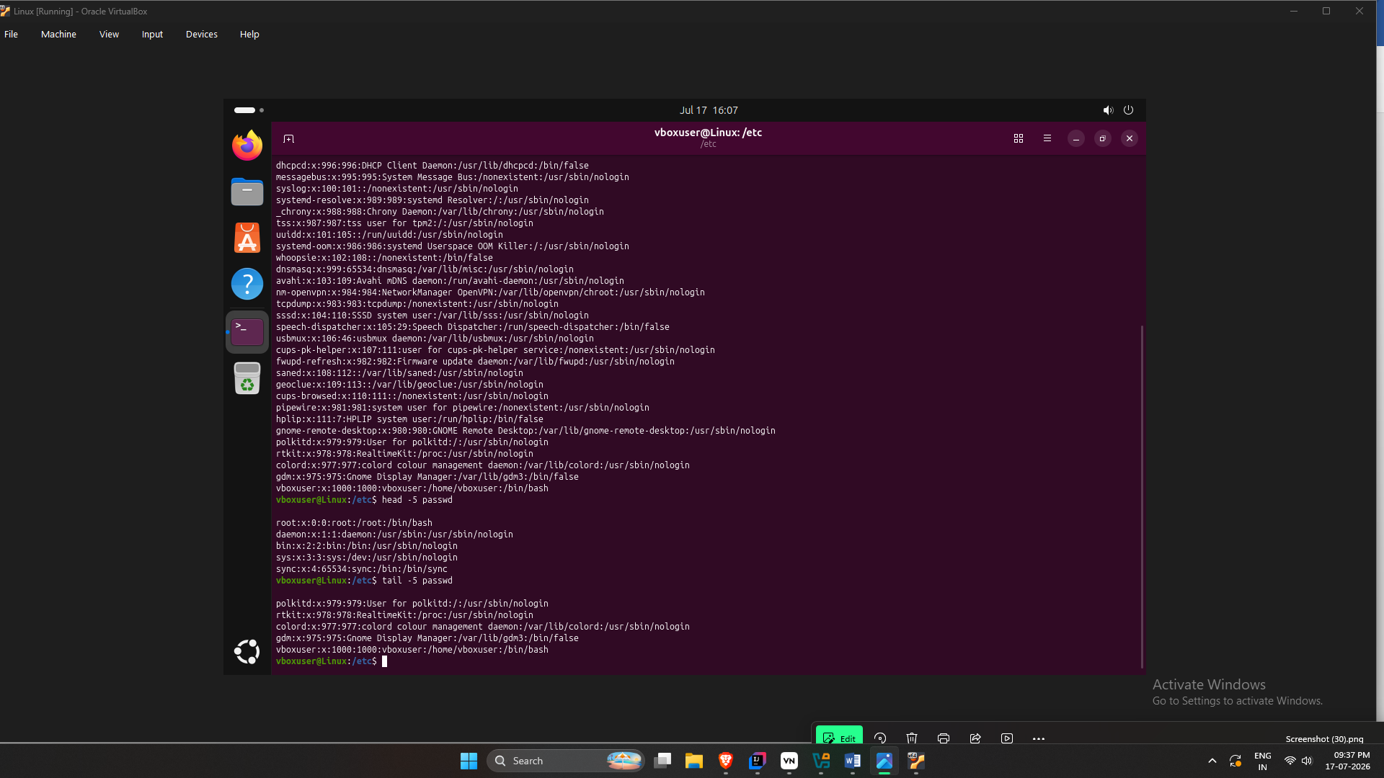

3.Searching for Patterns
Use grep to find all lines containing the word "root" in /etc/passwd.

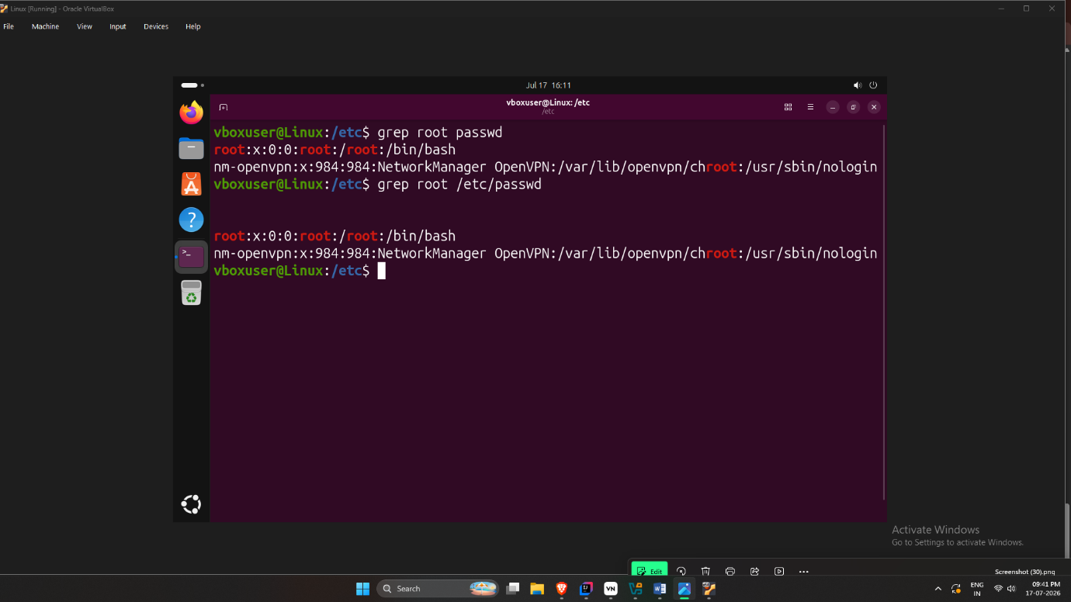

4. Zipping and Unzipping
Compress the test_dir directory into a file named test_dir.zip using zip.
Unzip test_dir.zip into a new directory named unzipped_dir.
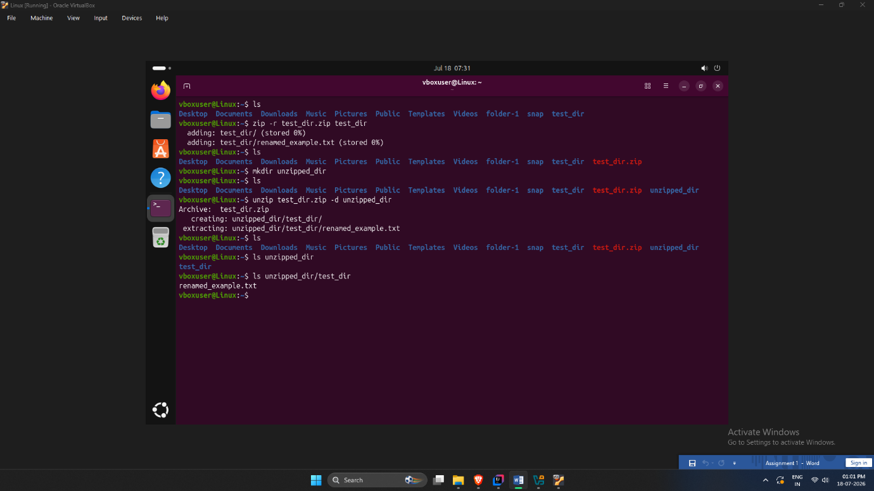
5. Downloading Files
Use wget to download a file from a URL (e.g., https://example.com/sample.txt).
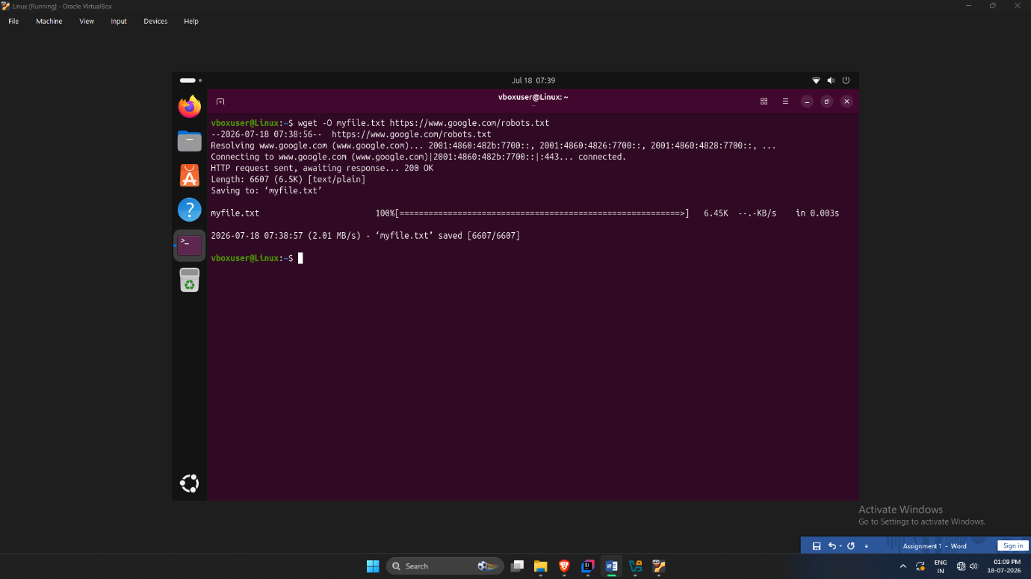

6. Changing Permissions
Create a file named secure.txt and change its permissions to read-only for everyone using chmod.

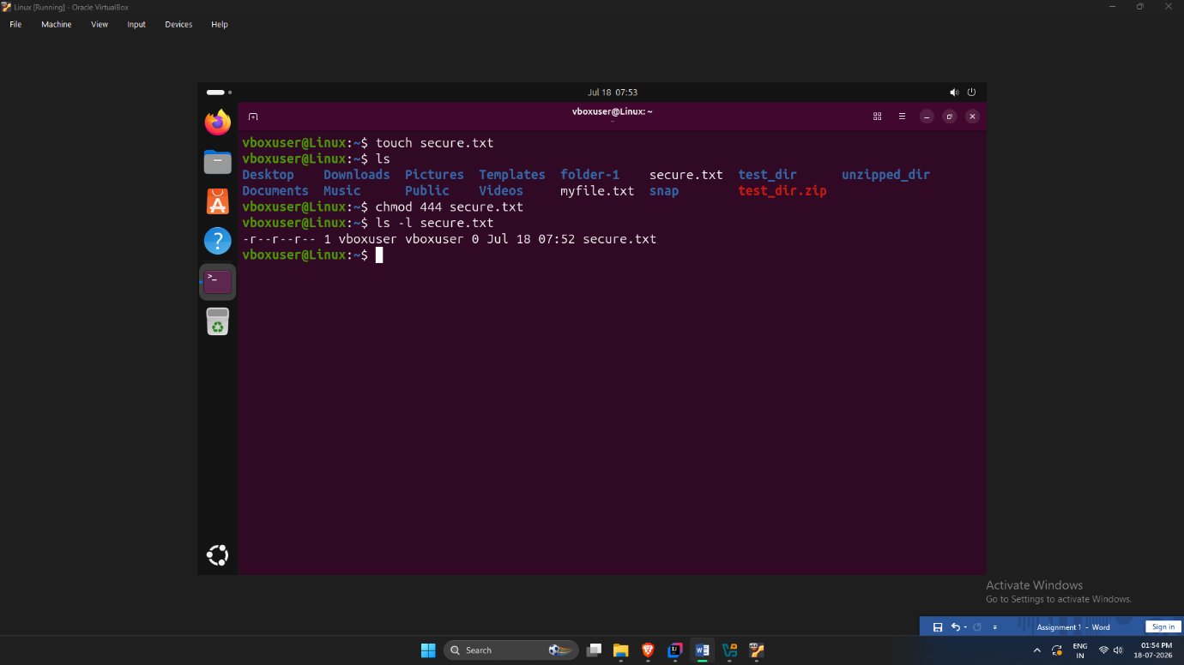
7. Working with Environment Variables
Use export to set a new environment variable called MY_VAR with the value "Hello, Linux!".



